Object Detection using Federated Learning

KOWSHIK THATINATI
B.Tech (Hons) CSE
KESHAV MEMORIAL COLLEGE OF ENGINEERING

Under the Guidance of
Dr. CHALAVADI VISHNU
Assistant Professor
Indian Institute of Technology, Tirupathi

1.Problem Statement and Motivation
Object detection is a fundamental computer vision task that involves identifying and locating objects in images or video streams. Most object detection models are trained using centralized datasets, where data from different sources is collected and stored in a single server. Although this approach achieves good performance, it raises serious concerns related to data privacy, security, and ownership, especially in sensitive domains such as autonomous systems, smart cities, and healthcare.
In practical scenarios, data is distributed across multiple devices or organizations, and sharing raw image data is often restricted due to privacy regulations. Federated Learning addresses this issue by enabling multiple clients to collaboratively train a shared model without transferring their local datasets. However, applying federated learning to object detection is challenging due to factors such as non-identical data distributions across clients, large model sizes, and increased communication overhead.
The motivation of this work is to develop a privacy-preserving object detection framework using federated learning. By combining federated learning with efficient object detection models such as YOLO, it becomes possible to train accurate models while ensuring that sensitive data remains local to each client. This approach reduces privacy risks and improves scalability in distributed environments.
2.Visual Representation of Federated Learning

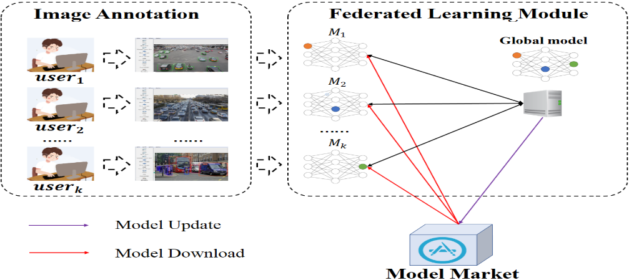
3.Literature Survey
In the last two years, researchers have explored applying Federated Learning to object detection to address privacy and data-sharing issues. Traditional object detection relies on centralized datasets, which is often not feasible due to legal, ethical, or security constraints. Federated Learning allows multiple clients to train a shared model without sharing their local data.
Most studies use YOLO models like YOLOv5, YOLOv7, and YOLOv8 because they balance accuracy and speed, and adapt them for applications such as smart surveillance, autonomous vehicles, and intelligent transportation. Research in Internet of Vehicles (IoV) showed that federated object detection can learn from distributed data while keeping it private. Yet, challenges such as non-identical data distributions and unstable convergence remain.
Some papers improved the standard FedAvg by using adaptive optimization, pretrained models, and communication-efficient methods. These help in stabilizing training and improving detection accuracy. Overall, federated learning is a promising approach for privacy-sensitive object detection, though challenges in performance and communication still exist.
4. Issues Faced by Authors
While recent research shows that Federated Learning can be applied to object detection, several challenges remain common across studies. One major issue is non-IID (non-identical) data; clients often collect data from different environments, so the distribution of objects varies widely. This makes it hard for the shared model to learn uniformly and slows convergence.
Another challenge is communication overhead. Object detection models like YOLO are large, and in a federated setup, frequent model updates need to be exchanged between clients and the server. This can consume significant bandwidth and increase training time, especially in real-time applications like autonomous vehicles or surveillance.
Model convergence instability is also observed. Unlike centralized training, federated training can converge slower and sometimes produce less accurate models due to variations in local training, batch sizes, and local learning rates.
Finally, privacy and security risks still exist. Although raw data is not shared, model updates can potentially leak sensitive information if not properly secured. Real-time constraints pose another challenge; object detection tasks often require fast inference, and federated setups can add latency if updates are frequent or models are heavy.
5. How Papers Addressed These Issues
Recent studies proposed several strategies to overcome challenges in federated object detection. For non-IID data, techniques like FedOpt, FedAvgM and pretrained model initialization were used to stabilize training and improve convergence. To reduce communication overhead, methods such as partial weight sharing, reduced update frequency, and model compression ensured collaborative training without network overload.
For model convergence instability, approaches like local training with multiple epochs and server-side momentum helped stabilize updates. Privacy and security were enhanced using secure aggregation, encryption, and differential privacy. Real-time constraints were addressed by using lightweight YOLO variants and minimizing computational load during inference, enabling deployment in autonomous vehicles and smart surveillance.
These combined strategies allow federated object detection to maintain good accuracy while ensuring privacy, communication efficiency, and training stability across distributed clients.
6. Results, Metrics, and Analysis
Recent works in federated object detection evaluated performance using metrics such as Mean Average Precision (mAP), Intersection over Union (IoU), and Frames Per Second (FPS) to measure accuracy, localization quality, and inference speed respectively. Studies show that federated models generally achieve slightly lower accuracy than centralized models due to distributed and heterogeneous data, but they offer significant privacy advantages.
The use of adaptive optimization, pretrained initialization, and lightweight architectures improved convergence and reduced communication costs, while maintaining real-time inference capabilities. Larger YOLO models delivered higher mAP but required more bandwidth, whereas lightweight variants achieved faster FPS suitable for real-time applications. Overall, the results indicate that federated object detection can balance accuracy, efficiency, and privacy, making it a practical solution for sensitive and distributed environments.

7. Implementation Overview
A typical implementation of federated object detection involves a client-server setup. The server initializes a pretrained YOLO model and distributes it to multiple clients (e.g., edge devices or simulated nodes on a local system). Each client performs local training on its private dataset for a few epochs and sends only the model weight updates back to the server. The server then performs weighted aggregation of these updates using algorithms like FedAvg or FedOpt to update the global model. This cycle repeats until the model converges.
To reduce communication cost, techniques such as partial weight sharing and model compression are applied. Privacy and security are maintained through secure aggregation and encryption of updates. Lightweight YOLO variants are preferred for real-time inference, especially when computational resources are limited.

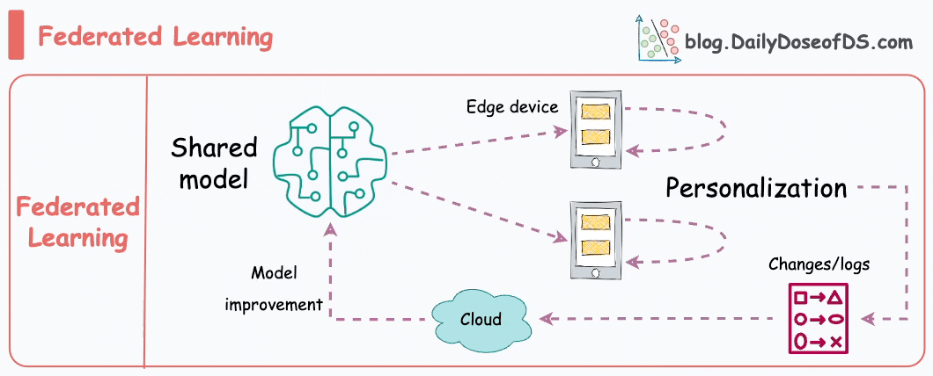
8. Conclusion
Federated Learning for object detection is a promising approach to train models while keeping data private and distributed. It allows multiple clients to collaboratively update a shared model without sharing raw data, addressing privacy, security, and compliance concerns. Although challenges like non-IID data, communication overhead, and convergence issues remain, methods such as adaptive optimization, pretrained initialization, secure aggregation, and lightweight YOLO models have improved performance. Overall, federated object detection provides a good balance of accuracy, efficiency, and privacy, making it suitable for applications like autonomous vehicles, smart surveillance, and IoT systems. Future work can focus on better aggregation, reduced communication cost, and personalization.

9. References
- C. Quéméneur and S. Cherkaoui, “FedPylot: Navigating Federated Learning for Real-Time Object Detection in Internet of Vehicles,” 2024.
- H. Zhang, Y. Li, and J. Wang, “Federated Object Detection for Autonomous Driving with YOLOv7,” IEEE Transactions on Intelligent Vehicles, 2023.
- S. Patel and R. Kumar, “Privacy-Preserving Federated Learning for Object Detection in Smart Surveillance Systems,” 2023.
- L. Chen, M. Zhao, and X. Liu, “Communication-Efficient Federated YOLO for Edge Devices,” Journal of Machine Learning Applications, 2024.

